Submit absence request on Gateway
Parents may submit absence requests for their child, for example sick leave, other planned leave etc.
- Login Gateway homepage, click on the Absence Request button of the child.
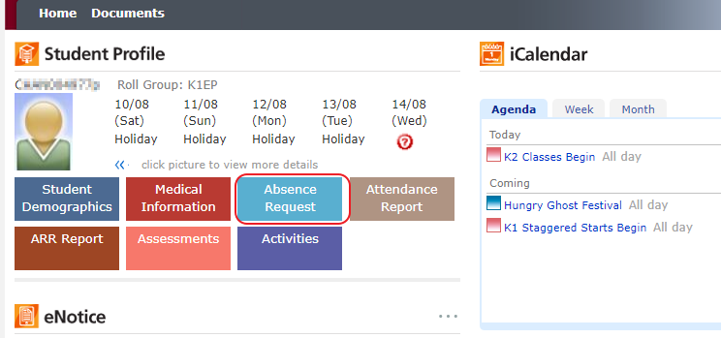
- Fill out the form, click the Submit button. There will be a confirmation Email to parents’ registered Email address.
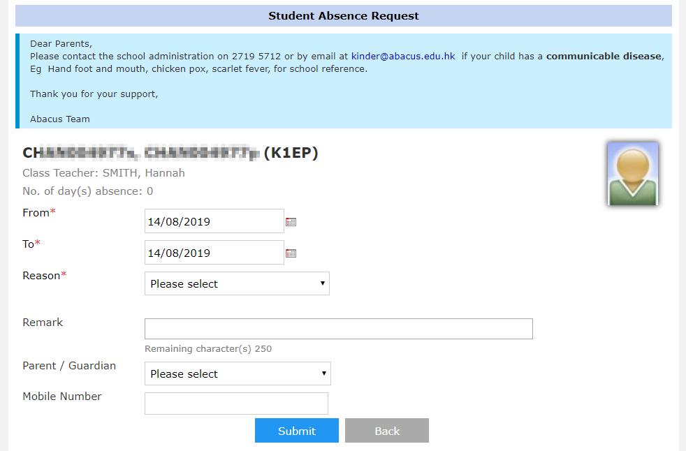

NOTE
- Parent may submit absence records for current day or future days
- Submitted records are not allowed update, please contact school if you wish to do so

